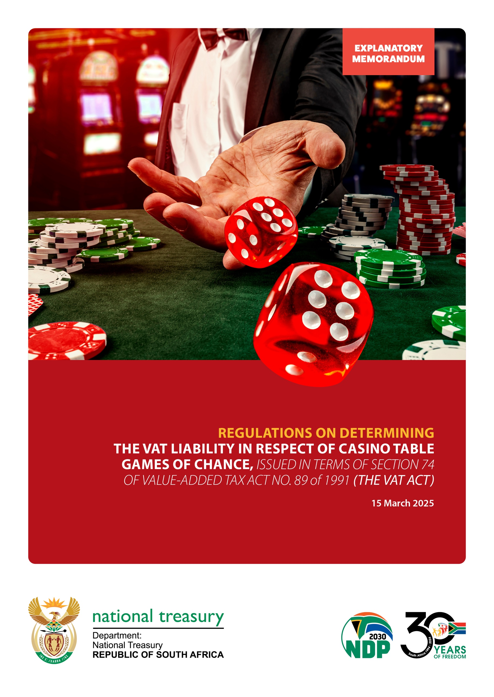

Table of Contents
1. BACKGROUND 1
2. REASONS FOR CHANGE 1
2.1 Gaming transactions 1
2.2 Calculation of table win or loss 2
3. DETAILED EXPLANATION OF THE REGULATIONS 2
3.1 Regulation 1: Definitions 2
3.2 Regulation 2: Accounting for VAT on the VAT201 3
4. EFFECTIVE DATE 3

- BACKGROUND
The gambling industry was permitted to account for value-added tax (VAT) by applying the tax fraction to the net betting transactions (on the amount remaining after winnings have been deducted which is known as the “net drop method”) for casino games of chance under the “section 72 arrangement” contained in Binding General Ruling 13 (issue 2) (BGR 13) that was issued on 22 March 2013.
Section 8(13) of the VAT Act deems the person with whom a bet is placed, to have supplied a service to the person that has bet an amount on the outcome of a race, or other event/occurrence. Section 16(3)(d) of the VAT Act allows a deduction equal to the tax fraction of amounts paid by a supplier in respect of betting services contemplated in section 8(13) of the VAT Act, as prizes or winnings to the recipient of such betting services.
The recent legislative amendment to section 72 of the VAT Act led to the expiry of BGR 13 on 31 December 2021 which has placed suppliers of table games of chance in difficulty when completing their VAT returns. As an interim measure, a decision was made under the amended provisions of section 72 of the VAT Act, which is contained in Binding General Ruling 59 that was issued on 13 December 2021, to prescribe a method for vendors to determine the VAT liability and account for VAT with regard to the supplies in relation to casino table games of chance.
The Regulations now brings that arrangement into the law.
- REASONS FOR CHANGE
The gambling industry does not work within the usual confines of the VAT Act and South Africa is one of a few countries that taxes betting transactions. A casino/bookmaker accounts for output tax on all bets placed and may deduct input tax on any winnings paid to punters. The nature of betting transactions in the casino industry, especially the table game of chance, makes it difficult to separate bets placed by punters and winnings paid to punters.
Considering the nature of the table game of chance, the number of punters, the number of bets placed, and the game’s speed, all of which are essential for running a successful table operation, it is practically impossible to record each bet and pay-out for a casino table game of chance. These practicalities in respect of a table game of chance make it virtually impossible to separate bets placed by punters and winnings paid to punters by gaming operators as can be noted from the process below.
  - Gaming transactions
The gaming transactions operate as follows for table games of chance:
- Table games operate with a variety of denominations of chips, for example, R100, R500, R1 000.
- A punter wanting to play on the tables buys-in with cash, a cash plaque, being a high denomination value representation obtained from the cash desk, by way of a cash withdrawal from the punter's casino card or by buying in with chips.
- Any cash, plaques or cash withdrawal slips are placed in the drop box (a sealed box attached to each table), whilst chips received are placed in the table’s chip tray, where all chips not in play, are kept.
- All bets are placed with chips, which if lost, get returned to the chip tray. All winning bets are paid out to the punter with chips from the chip tray.
- In case of a shortage of a certain denomination of chips on the table, the table obtains a “fill” from the cash desk. The fill is documented by placing one copy of the fill slip in the drop box.
- In case of a surplus of chips in the chip tray, the table can return chips to the cash desk, which is also documented by placing one copy of the “credit slip” in the drop box.
- Due to the number of punters, the number of bets being placed, and the speed of the game, all of which are essential for running a successful table operation, it is virtually impossible to record each bet and pay out for a casino table game.
  - Calculation of table win or loss
In practice, the table win, or loss is calculated as follows:
- Drop (cash, plaques and cash withdrawal slips), plus closing float of chips in the chip tray, minus opening float of chips in the chip tray, minus fills, plus credits.
- The result is the table win or loss, which is relevant for accounting purposes and for determining the operator's liability for gaming tax in terms of the relevant provincial Gambling Regulations.
- The win per table is determined every 24 hours.
Based on the above, the gambling industry experiences difficulties in reflecting output tax under section 8(13) of the VAT Act, separately from input tax deducted under section 16(3)(d) of the VAT Act, for purposes of completing the VAT201 return.
- DETAILED EXPLANATION OF THE REGULATIONS
The Regulations are for prescribing the “gross gaming revenue” as a method for determining the VAT liability in respect of casino table games of chance.
  - Regulation 1: Definitions
    - “Casino”
The term “casino” means a “casino”, as defined in section 1 of the National Gambling Act, 2004 (Act 7 of 2004) (“the National Gambling Act”) that is operated by a person that is “licensed”, as contemplated in section 1 of that Act, and is a registered vendor. The proposed amendment will clarify what is meant to be a “casino” and the group of vendors affected by the Regulations.
    - “Gross gaming revenue”
The term "gross gaming revenue” is an amount determined, under the applicable provincial gambling legislation, for each table game. It is determined by the closing bankroll plus credit slips for cash, chips or tokens returned to the casino cage, plus drop, less opening bankroll and fills to the table. The proposed amendment clarifies the amount to be recognized as the “gross gaming revenue”.
    - “Table game of chance”
The term “table game of chance” means a “gambling game”, as defined in the National Gambling Act, that -is played against the casino and operated by one or more live croupiers. The proposed amendment clarifies the type of game the Regulations refer to.
  - Regulation 2: Accounting for VAT on the VAT201
A casino may account for VAT on its VAT returns in respect of table games of chance, on the “gross gaming revenue”, for the relevant tax period, subject to the following:
    - Gross gaming revenue in respect of table games of chance must be included in field 1 of the VAT return, with the tax fraction applied to that amount reflected in field 4.
    - Casinos are not entitled to any deductions under section 16(3)(d) of the VAT Act if such an amount has been included in calculating the gross gaming revenue.
    - Casinos are required to maintain adequate records to enable SARS to verify the validity and accuracy of the tax liability calculated and included in the VAT return, as set out above, and in particular, the records for the purpose of audits conducted by the provincial Gaming Boards.
- EFFECTIVE DATE
The Regulations come into effect on 1 January 2025.

